SIMATS ENGINEERING
ASSESSMENT TOOL 3

COURSE NAME: COMPUTER NETWORKS COURSE CODE: CSA07

COURSE OUTCOME COVERED

CO4:
Design network topologies star, mesh, bus, and hybrid using networking devices, transmission media, and cabling standards (BL2,BL6)

Assessment Tool Weightage: 30%

QUESTIONS: 5 Total Marks:25

Annexure A

Comparative Analysis

Code of Conduct:

I DAKSHIN.S(192511431) (Name / Reg No) certify that this submission is my original work and that I have adhered to the guidelines specified for this assessment.
I understand that any violation of academic integrity rules will result in disciplinary action.

Signature of the student:
DAKSHIN.S

1.Star topology is generally more expensive than bus topology because it requires a central device such as a switch or hub and more cabling to connect each node individually. In contrast, bus topology uses a single backbone cable, making it low-cost and easier to install. However, in terms of reliability, star topology is superior because failure of one node does not affect others, whereas a failure in the main bus cable can bring down the entire network. Performance is also better in star topology since data transmission is managed through a central device, reducing collisions, while bus topology suffers from performance degradation as more devices are added due to increased data traffic on the shared medium.
Answer:
Star Topology vs Bus Topology
Star topology is generally more expensive than bus topology because it requires a central networking device such as a switch or hub. Each computer or node must be connected separately to the central device using individual cables. Therefore, it requires more cables and installation work. On the other hand, bus topology uses a single backbone cable to connect all the devices, so it is cheaper and easier to install.
In terms of reliability, star topology is better than bus topology. In a star network, if one computer or its cable fails, the other computers can continue to communicate normally. However, if the central switch or hub fails, the entire network can be affected. In bus topology, if the main backbone cable fails, the entire network may stop working.
In terms of performance, star topology provides better performance because the central switch controls and forwards data between the connected devices. This helps reduce unnecessary traffic and collisions. Bus topology uses a shared communication medium, so all devices share the same cable. When more devices are added, network traffic increases and the performance becomes slower.
Star topology is also easier to manage and troubleshoot because each device has a separate connection to the central switch. If a problem occurs, it is easier to identify the faulty device or cable. In bus topology, finding a fault in the main cable can be more difficult.
Conclusion
Overall, bus topology is cheaper and simpler, making it suitable for small and temporary networks. Star topology is more expensive but offers better reliability, performance, scalability, and easier maintenance. Therefore, star topology is commonly preferred in modern computer networks.
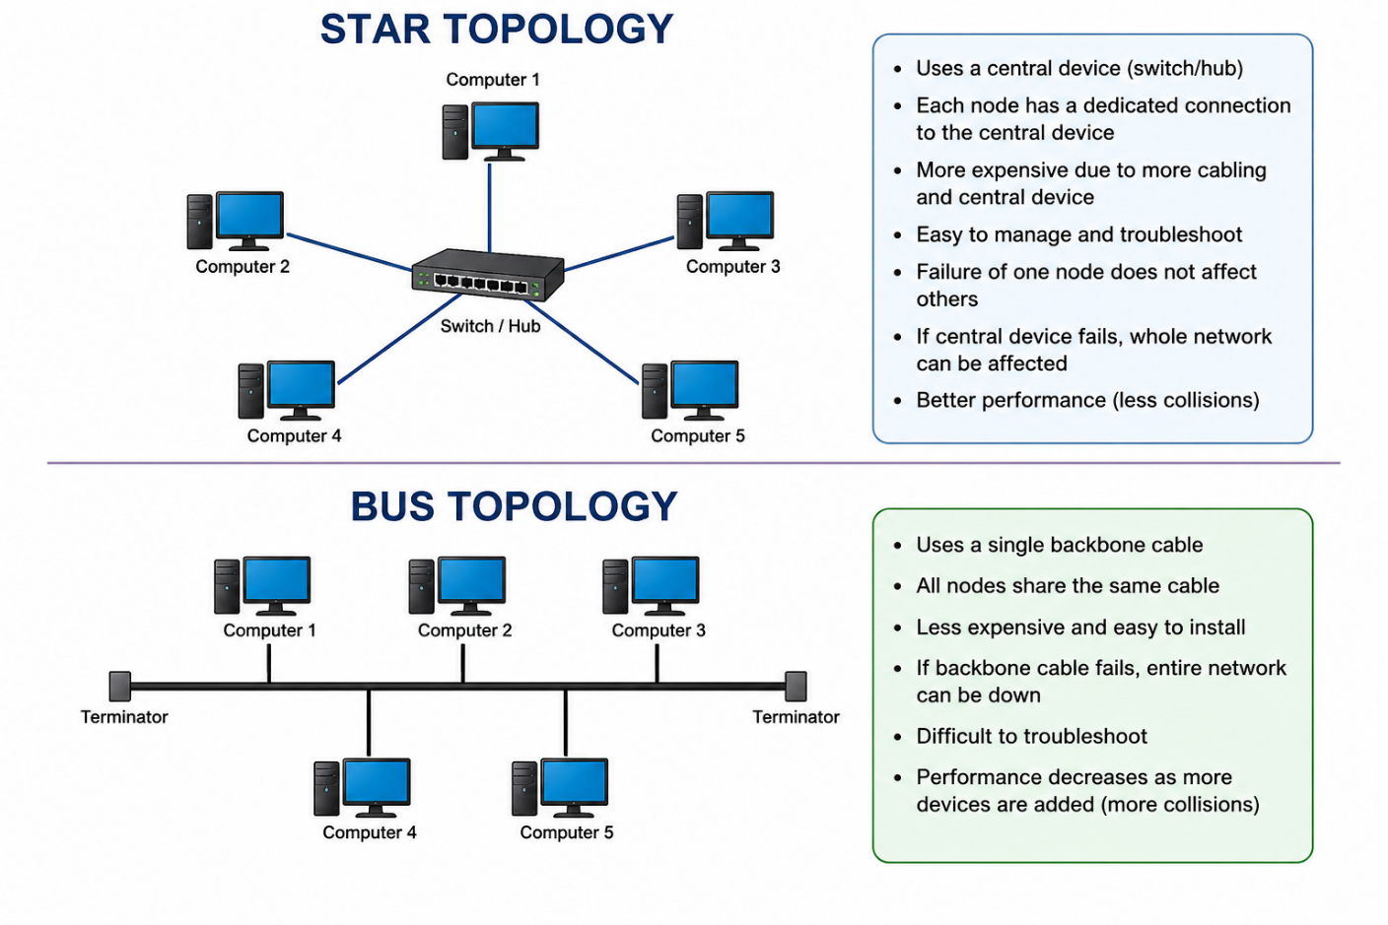

2.Mesh topology offers very high fault tolerance because every node is connected to multiple other nodes, providing multiple paths for data transmission. If one link fails, data can still be routed through alternate paths without disrupting communication. In contrast, star topology has moderate fault tolerance; while failure of individual nodes does not affect the network, failure of the central hub or switch can cause the entire network to stop functioning. Therefore, mesh topology is more robust and reliable in critical environments compared to star topology.
Answer:
Mesh topology offers very high fault tolerance because every node is connected to multiple other nodes. This means that there are several different paths available for data to travel from one device to another. If one cable or connection fails, the data can automatically use another available path. Therefore, the failure of a single link usually does not affect the overall communication in the network.
In star topology, all devices are connected to a central hub or switch. It provides moderate fault tolerance. If the cable connecting one computer to the switch fails, only that particular computer is affected, while the other computers can continue communicating normally. However, the main disadvantage is that the central hub or switch is a single point of failure. If it stops working, all connected devices may lose network communication.

Comparison

Feature | Mesh Topology | Star Topology
Fault tolerance | Very high | Moderate
Data paths | Multiple paths | Mainly through central switch
Single cable failure | Network continues | Only one node affected
Central device failure | No central device | Entire network can stop
Reliability | Very high | Good
Cost | High | Lower than mesh
Maintenance | More difficult | Easier
Suitable for | Critical networks | Offices, schools, homes

Example
Suppose there are five computers in a network. In a mesh topology, each computer has multiple connections to other computers. If one cable is damaged, the computers can still communicate using another connection.
In a star topology, all five computers are connected to one central switch. If the connection between one computer and the switch fails, only that computer is disconnected. But if the central switch fails, all five computers lose network connectivity.

Conclusion
Therefore, mesh topology is more robust and reliable than star topology in terms of fault tolerance. Its multiple connections provide alternative routes for data, reducing the effect of individual link failures. However, mesh topology requires more cables, ports, and installation cost. Star topology is simpler and cheaper, but its dependence on a central switch makes it less fault-tolerant. For critical environments where continuous communication is required, mesh topology is generally preferred.

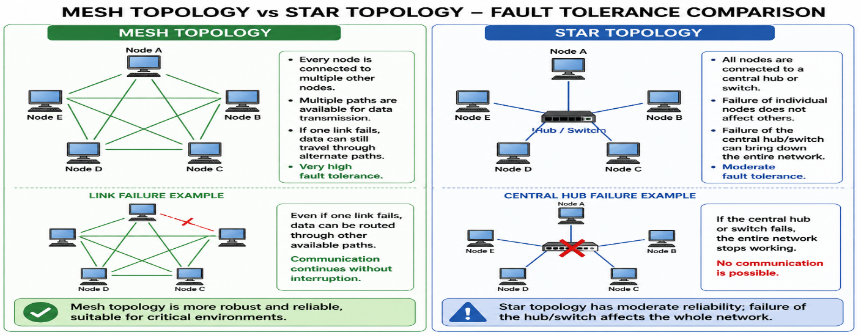

3.Bus topology is simple and easy to install because it uses a single backbone cable with minimal connections, making it suitable for small networks. On the other hand, mesh topology is highly complex to install as each node must be connected to every other node, requiring a large number of cables and ports. This complexity increases significantly as the number of devices grows, making mesh topology time-consuming and costly to implement compared to the straightforward setup of bus topology.
Answer:
Bus topology is simple and easy to install because it uses a single backbone cable to connect all the devices in the network. Each computer or device is connected to this main cable using a simple connection. Since fewer cables and networking devices are required, the installation process is straightforward, quick, and inexpensive. This makes bus topology suitable for small networks where only a few devices need to be connected.
In contrast, mesh topology is much more complex to install. In a full mesh topology, every device must have a direct connection with every other device. As the number of devices increases, the number of cables and network ports required also increases rapidly. This makes installation more difficult, time-consuming, and expensive.
For example, if there are 5 devices in a full mesh network, many individual connections are required between the devices. If more devices are added, additional connections must be created between the new device and the existing devices. Therefore, managing and installing a large mesh network can become complicated.
Comparison
Feature | Bus Topology | Mesh Topology
Installation | Very easy | Complex
Cable requirement | Low | Very high
Number of connections | Few | Many
Installation time | Less | More
Cost | Low | High
Maintenance | Relatively easy | Difficult
Expansion | Simple for small networks | Complex
Suitable for | Small networks | Critical and large networks

Example
Consider a small computer lab with 5 computers. In a bus topology, all five computers can be connected to one backbone cable. This requires fewer cables and connections, so the network can be installed quickly.
In a mesh topology, each computer needs connections to the other computers. Therefore, many cables are required. If the number of computers increases, the number of connections also increases, making the network increasingly difficult to install and manage.
Conclusion
Therefore, bus topology is much simpler and cheaper to install than mesh topology. Bus topology uses a single backbone cable and requires minimal connections, making it suitable for small and simple networks. Mesh topology provides better reliability and fault tolerance, but its large number of connections makes installation more complex, time-consuming, and expensive.

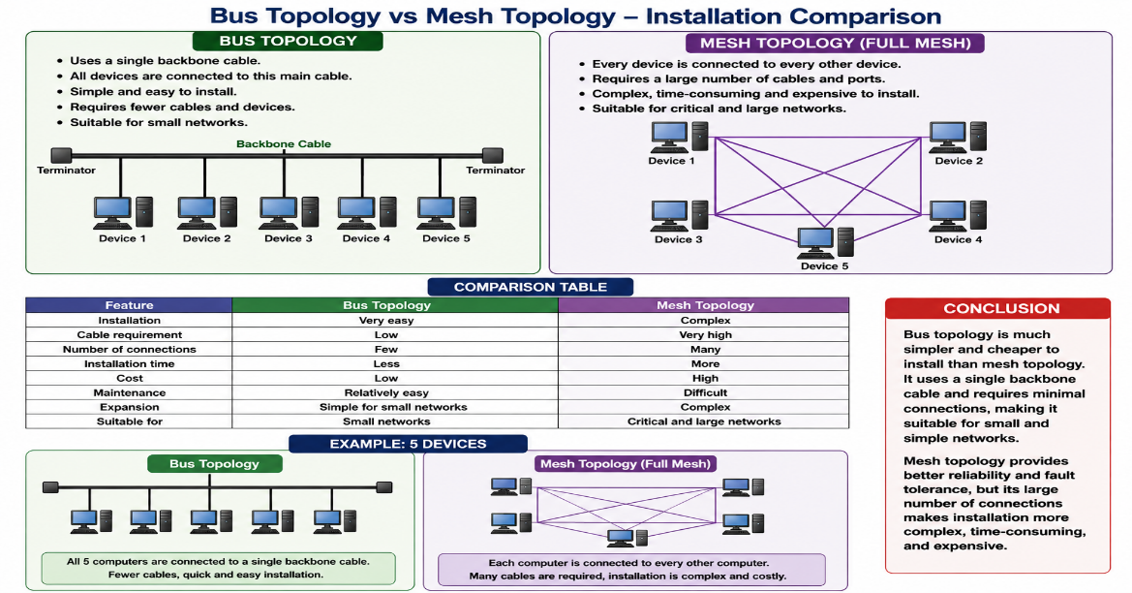

4.Hybrid topology is highly scalable because it combines two or more different topologies (such as star, mesh, or bus), allowing the network to expand flexibly according to organizational needs. New segments can be added without affecting the existing network structure. In comparison, star topology is also scalable but to a limited extent, as it depends on the capacity of the central device (switch or hub). Once the central device reaches its port limit, expansion requires additional hardware. Thus, hybrid topology provides greater scalability than star topology.
Answer:
Hybrid topology is highly scalable because it combines two or more different network topologies, such as star, bus, mesh, or ring topology. This combination allows an organization to design and expand the network according to its specific requirements. New sections or network segments can be added without making major changes to the existing network structure.
For example, an organization may use star topology in one department and mesh topology in another department. These different sections can be connected together to form a hybrid network. If the organization grows and a new department is added, a new network segment can be connected to the existing hybrid network. This makes hybrid topology flexible and suitable for large organizations and growing networks.
In comparison, star topology is also scalable, but its scalability is limited by the capacity of the central hub or switch. Every device must be connected to this central device. If all the available ports are already being used, adding more computers requires an additional switch or other networking hardware.
For example, if a switch has 8 ports and all 8 ports are occupied, another device cannot be directly connected unless an additional switch is installed. Therefore, expansion can increase the hardware requirements and cost.

Comparison
Feature | Hybrid Topology | Star Topology
Scalability | Very high | Moderate to high
Expansion | Flexible | Depends on central device
Network structure | Combination of topologies | Centralized
Port limitation | More flexible | Limited by switch/hub ports
Additional hardware | Can be added as required | Often required for expansion
Flexibility | Very high | Moderate
Suitable for | Large and growing organizations | Small and medium networks
Example
Suppose a company has three departments. In a hybrid topology, each department can use a different topology based on its requirements. If the company adds a new department, another network segment can be created and connected to the existing network.
In a star topology, all computers need to connect to the central switch. If the switch has no free ports, the company must install another switch to connect additional devices.

Conclusion
Therefore, hybrid topology provides greater scalability than star topology. It allows different network topologies to be combined and new network segments to be added according to organizational requirements. Star topology is also relatively easy to expand, but its growth depends mainly on the capacity and number of ports of the central switch or hub. Hence, hybrid topology is more flexible and suitable for large, complex, and continuously growing networks.

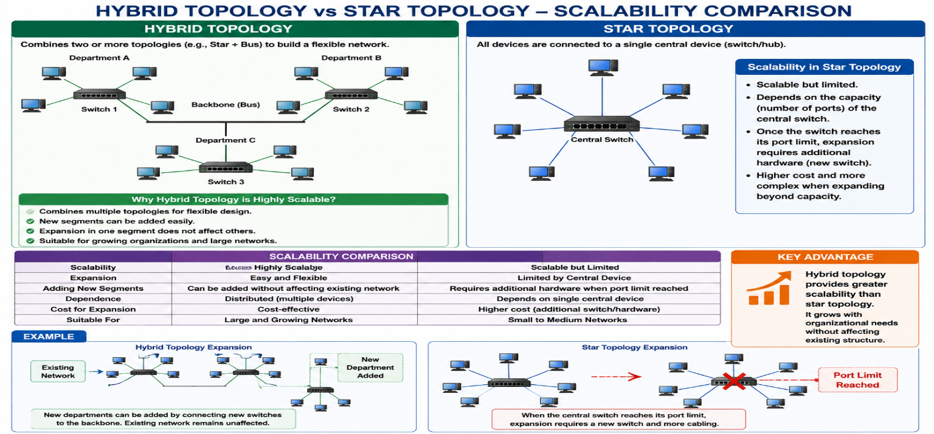

5.In terms of maintenance, star topology is relatively easy to manage because issues can be quickly identified and isolated to a specific node or cable. Mesh topology, while highly reliable, is difficult to maintain due to its complex structure and large number of connections, making troubleshooting time-consuming. Bus topology is harder to maintain than star because faults in the backbone cable can disrupt the entire network and are difficult to locate. Hybrid topology has moderate maintenance complexity; while it benefits from flexibility, managing multiple combined topologies requires careful monitoring and skilled administration.

Answer:
In terms of maintenance, different network topologies have different levels of difficulty. Among these, star topology is the easiest to maintain, while mesh topology is the most difficult because of its large number of connections. Bus and hybrid topologies have moderate to high maintenance requirements depending on their network structure.
1. Star Topology
Star topology is relatively easy to maintain and manage because all devices are connected to a central hub or switch. If a particular computer or cable develops a problem, the issue can usually be identified and isolated quickly. The other devices can continue to communicate normally.
For example, if one computer's network cable is damaged, only that computer is disconnected. The administrator can check that particular cable or port without disturbing the rest of the network.
Therefore, star topology is commonly preferred because it provides simple troubleshooting, easy maintenance, and better fault identification.
2. Mesh Topology
Mesh topology is highly reliable but difficult to maintain because it contains a large number of connections between devices. Each device may have multiple links to other devices, so identifying and repairing a faulty connection can take more time.
Although the failure of one connection may not affect the entire network because alternative paths are available, the administrator must check many cables and connections when troubleshooting.
Therefore, mesh topology provides excellent reliability but requires more time, effort, and skilled technical knowledge for maintenance.
3. Bus Topology
Bus topology is harder to maintain than star topology because all devices share a common backbone cable. If there is a problem with the backbone cable, communication across a large part or the entire network can be affected.
Finding the exact location of a fault in the long backbone cable can also be difficult. The administrator may need to check different sections of the cable to identify the problem.
Therefore, bus topology has more difficult troubleshooting and maintenance compared with star topology.
4. Hybrid Topology
Hybrid topology has moderate maintenance complexity because it combines two or more different topologies, such as star, mesh, bus, or ring. Each section may have its own structure and maintenance requirements.
The advantage is that problems can sometimes be isolated to a particular section of the network. However, managing different types of network structures requires careful monitoring, proper configuration, and skilled network administrators.
Comparison
Example
Consider an office with several computers. In a star topology, if one computer stops connecting to the network, the administrator can simply check its cable or switch port. This makes troubleshooting quick.
In a mesh topology, there may be many connections between the computers. If one connection fails, the network may continue working, but finding the faulty connection can require checking several links.
In a bus topology, a problem with the main backbone cable can affect many or all devices, making the fault more difficult to locate.
In a hybrid topology, the administrator must understand the different topologies used in each section before troubleshooting the network.

Conclusion
Therefore, star topology is the easiest to maintain, as faults can be quickly identified and isolated. Mesh topology is the most difficult to maintain because of its complex structure and large number of connections. Bus topology is also difficult to maintain because a backbone cable failure can affect the entire network. Hybrid topology has moderate maintenance complexity because it combines different topologies and requires careful monitoring and skilled administration.

